

AIRLINE RESERVATION SYSTEM

MINI-PROJECT S1



*SRMIST CSE AI ML*

*18CSS101J-NALLARASAN SIR*

**MINI PROJECT - C LANGUAGE**

**SRMIST 1ST YEAR – CSE AI & ML (S1)**

PROGRAMMING FOR PROBLEM-SOLVING

TITLE : AIRLINE RESERVATION SYSTEM

NAMES-ID : Prakhya Pragnya Shri-RA2111026010004

Shashank Reddy.A -RA2111026010028

Sanjay.G-RA2111026010025

Armaan Parnami-RA2111026010019

Introduction

Originally, the C language is developed from two previous languages, BCPL and B. BCPL which were developed in 1967 by Martin Richards as a language for wringing operating systems and compilers. C was evolved from B by Dennis Ritchie at Bell Laboratories and it was implemented in 1972. It initially became widely known as the development language of the UNIX operating system. Lots of today’s leading operating systems are written in C and C++. C language is mostly hardware independent as it is possible to write C programs that are portable to most computers.

Why we use c language C has been used successfully for each kind of programming problem thinkable from operating systems to spreadsheets to expert systems - and efficient compilers are accessible for machines ranging in power from the Apple Macintosh to the Cray supercomputers. the largest measure of C's success appears to be based on strictly sensible considerations:

The standard library concept;

the ease with that applications can be optimized by hand-coding isolated procedures;

a powerful and varied repertoire of operators;

the portability of the compiler;

**Project Explanation:**

The project is Airline Reservation System:

Our main aim is to write a program to assign seats on each flight of the airlines only place (capacity: 15 seats).

The program should never assign a seat that is already assigned. If there’s no seat available, then print the message " the flight is full ".

After the flight is full and someone wants to cancel the booking, it is displaying enter you’re the passport number you want to cancel it so after the passenger cancels it, the system directly free that place if someone wants to book that seat.

Moreover, the system should bring a boarding pass indicating the persons' name, passport number, and seat number as each seat is assigned, set the corresponding elements of the array to 1 to indicate that the seat is no longer available.



**FLOW CHART**

1.Main menu



When the program is started, the user will direct to the main menu. The user will be required to select one of the four options.

2.Reservation and 3.cancel functions



These are the flowcharts for the reservation and cancel functions

4.Displaying Function.



That is the flowchart for the displaying function

**Pseudocode**

Begin

Declare Choice Repeat

repeat

display “welcome to our airlines”

display “Airline Seat Selection

1.Reservathion

2.Cancel

3.Dispaly layout

4.Exit

Enter your choice”

Accept choice

If (choice = 1)

Call R ()

Else

If (choice = 2)

Call C ()

Else

If (choice = 3)

Call D ()

Else

If (choice = 4)

Call E ()

Else

Print “Invalid choice”

End-If

End-If

End-If

End-If

Until (choice <> 4)

End

Function reservation ()

Declare passport number, name, num, email, contact number

Print “Enter your passport number”

Accept passport number

Print “Enter your name”

Accept name

Print “Enter your email “

Accept email

Print “Enter your contact number”

Accept contact number

IF (seats >15)

Print No Seats Available

ELSE

IF

(Seats <=15)

Print “registered successfully”

END-IF

END-IF

END-FOR

Return

Function Cancel ()

Declare Passport number

Print “Enter passport number to delete record”

Accept passport number

Do while (not end of records)

IF (passport = record _passport)

Delete record

Return

END-IF

Read next record

END-do

print

Return

Function Display layout ()

Do while (not end of records)

Display Record

Read next record

End -do

Return

C source code

#include<stdio.h>

#include<stdlib.h>

#include<conio.h>

#include<string.h>

struct srm_airline

{ char passport[6];

char name[15];

int seat_num;

char email[15];

struct srm_airline*following;

}

*begin,*stream;

struct srm_airline*dummy;

void main()

{ void reserve(int x),cancel(),display(),savefile();

int choice;

begin=stream=NULL;

int num=1;

do

{printf("\n\n\t\t *****************************************");

printf("\n\t\t ******Welcome to SRM AIRLINE SYSTEM******");

printf("\n\n\n\t\t Please Enter your choice from below(1-4):");

printf("\n\n\t\t 1.RESERVATION");

printf("\n\n\t\t 2.CANCEL");

printf("\n\n\t\t 3.DISPLAY RECORDS");

printf("\n\n\t\t 4.EXIT");

printf("\n\n\t\t Feel free to ask us-");

printf("\n\n\t\t Enter your choice:");

scanf("%d",&choice); fflush(stdin);

system("cls");

switch(choice)

{

case 1:

reserve(num);

num++ ;

break;

case 2:

cancel();

break;

case 3:

display();

break;

case 4:

{ savefile();

break;

}

default:

printf("\n\n\t SORRY INVALID CHOICE");

printf("\n\n\t PLEASE CHOOSE FROM 1-4");

printf("\n\n\t Do not forget to choose from 1-4");

}

getch();

} while (choice !=4);

}

//*GOOD LUCK**//

void details()

{

printf("\n\t Greetings!");

gets(stream->passport); fflush(stdin);

printf("\n\t Enter your passport number:");

gets(stream->passport); fflush(stdin);

printf("\n\t Enter you Name:");

gets(stream->name); fflush(stdin);

printf("\n\t Enter your Email address:");

gets(stream->email); fflush(stdin);

}

//*GOOD LUCK**//

void details();

void reserve(int x)

{ stream=begin;

if (begin==NULL)

{

//First User//

begin=stream=(struct srm_airline*)malloc(sizeof(struct srm_airline));

details();

stream->following=NULL;

printf("\n\t Seat Booking Succesful!");

printf("\n\t Your seat number is: Seat A-%d",x);

stream->seat_num=x;

return;

}

else if(x>15)

{

printf("\n\n Seats Full");

return;

}

else

{

//next User

while(stream->following)

stream=stream->following;

stream->following=(struct srm_airline*)malloc(sizeof(struct srm_airline));

stream=stream->following;

details();

stream->following=NULL;

printf("\n\t Seat Booking Succesful!");

printf("\n\t Your seat number is: Seat A-%d",x);

stream->seat_num=x;

return;

}

}

//*GOOD LUCK**//

void savefile()

{ FILE*fpointer=fopen("airline records","w");

if (!fpointer)

{ printf("\n Error in opening file");

return;

}

stream=begin;

while (stream)

{ fprintf(fpointer,"%-6s",stream->passport);

fprintf(fpointer,"%-15s",stream->name);

fprintf(fpointer,"%-15s",stream->email);

stream=stream->following;

}

printf("\n\nt Details have been saved to a file(airline records)");

fclose(fpointer);

}

//*GOOD LUCK**//

void display()

{ stream=begin;

while(stream)

{

printf("\n Passport Number:%-6s",stream->passport);

printf("\n Name:%-15s",stream->name);

printf("\n Email address:%-15s",stream->email);

printf("\n Seat number: A-%d",stream->seat_num);

printf("\n\n++=============================================================++");

stream=stream->following;

}

}

//*GOOD LUCK**//

void cancel()

{

stream=begin;

system("cls");

char passport[6];

gets(passport); fflush(stdin);

printf("Enter Passport number to delete record?:");

gets(passport); fflush(stdin);

if (strcmp(begin->passport,passport)==0)

{

dummy=begin;

begin=begin->following;

free(dummy);

printf("Booking has been deleted");

return;

}

while(stream->following)

{

if(strcmp(stream->following->passport,passport)==0)

{

dummy=stream->following;

stream->following=stream->following->following;

free(dummy);

printf("Booking has been deleted");

getch();

return;

}

stream=stream->following;

}

printf("Passport Number is wrong PLEASE check your passport");

}

//*GOOD LUCK**/

**REPORT**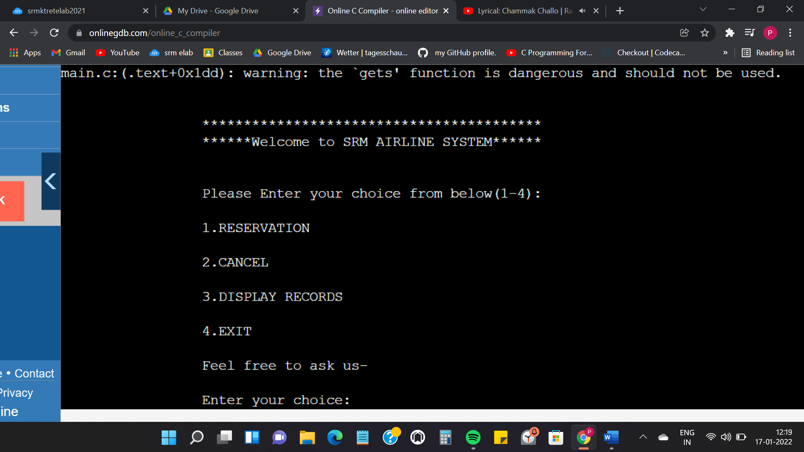

Main Menu

When the program is executed, the user will be directed to the main menu interface. The program is introduced with a few lines of text. Then four selections are made for the user as the user can choose to reserve, cancel, display or exit the program.

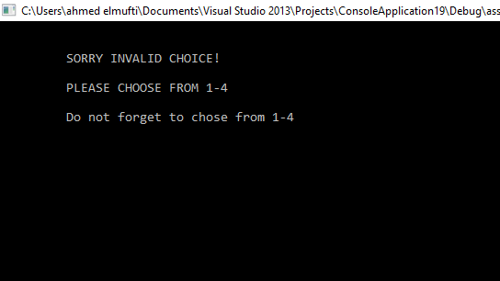

Invalid value

. If the user accidentally enters an invalid input, an interface will be shown to notify the user to choose again and it notify the user again to enter from 1-4.

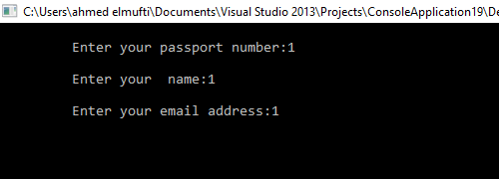

reservation function

The program is asking the user to enter passport number, name, and email address to reserve a seat for the user and the seat cannot be book for anyone else.

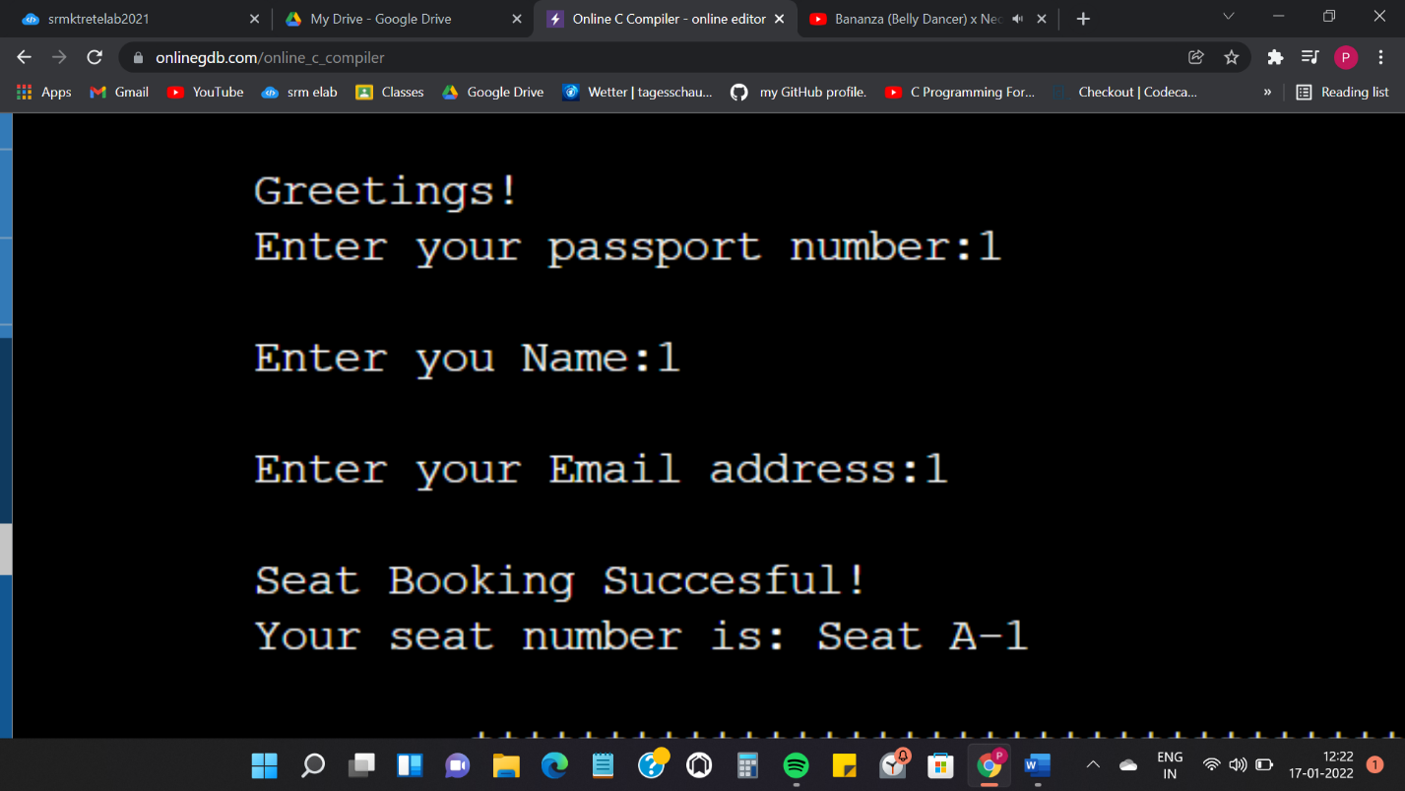

seat has successfully booked

As shown in the interface the seat reservation has been booked successfully, after the user has entered the details.

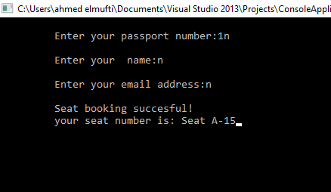

15 is the maximum seat number

The program could not book any more seat

After registering 15 users in the system now the flight is supposed to be full and cannot except anymore.

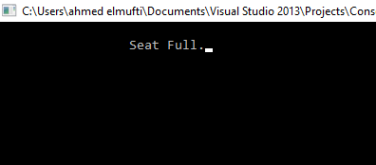

no more seat available

The system will pop out to notify the user that there’s no seat available, the flight contains only 15 seat after that it is displaying it is full sorry we cannot register anymore.

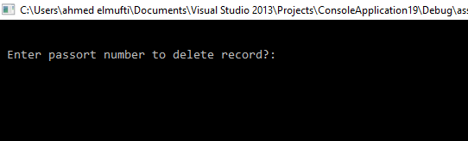

cancel function

After the passenger entered 3 and want to cancel the record, after that, the program requires the user to enter which passport number to delete it. For example, that Person A registered the seat on the flight and he wants to cancel it.

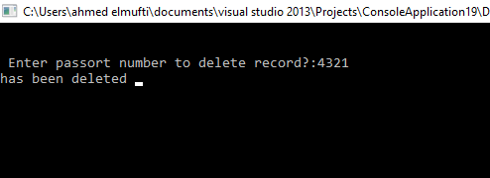

The system askes A to enter his passport number to cancel it from the system without any problems and in an efficient way. After “A” entered his passport number the system pop in your record has been deleted from the system.

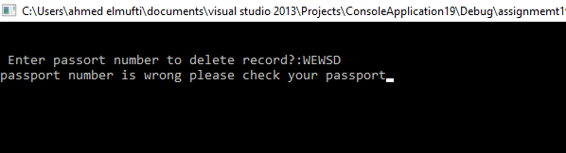

If “A” entered the wrong passport number by mistake the system pop in hey passport number is wrong, please check your passport number and enter it again.

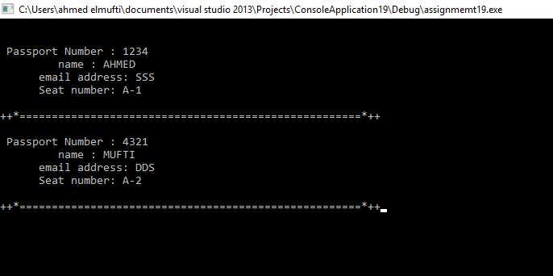

The interface is displaying all the user’s records that now you have two seats Ahmed with his details and “A” with his details as well. There’s a line between the users to make it clear to read and do not misunderstand it.

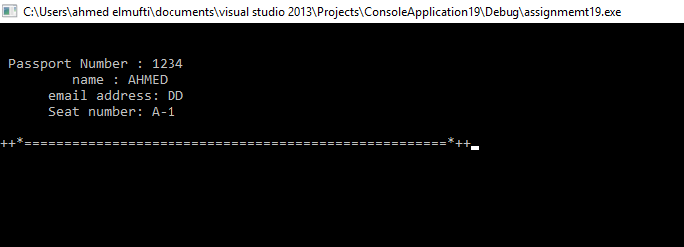 display function

After “A” cancel his seat from the system, the interface is showing that only One person is in the system and A’s seat already deleted.

after entered 4 which is exit function, it is storing all the records into file with all the passenger’s details in Airline record.

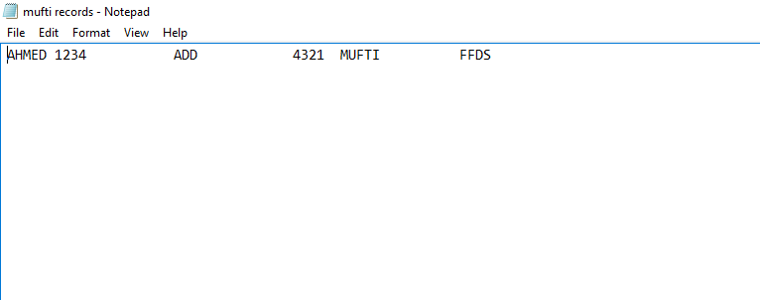

The interface is showing the record in notepad which is the storing part and it is displaying ahmed and his details after “A” cancel his record.

**Conclusion**

The Airline reservation system is designed for users to reserve a seat, cancel, display seats and exit the system. A formula is included in the function to calculate the seats are reserved. Pseudocode is written for some important codes. A few flow charts are also created for explaining the process of the Airline reservation system.

From this Project, I have learned to implement a few C concepts in future projects such as functions, switch statements and do…while statements, arrays, pointers, and structures in the program. I have also learned to create flow charts for explaining the program.

~THANK YOU!